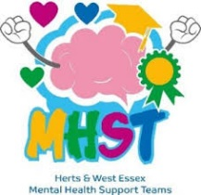
Mental Health Support Teams in Schools - Uttlesford



This is our final newsletter of the school year. It has been a pleasure working in all our schools with parents and children and young people.

During this school year we have carried out over 350 face to face interventions with parents in primary schools and young people in our secondary schools.
Group work with our schools has been delivered to over 2000 children in the form of Brain Buddies, Emotion Explorers, Friendships & Anxiety. We have visited many schools to attend coffee mornings, parent’s evenings, sports days and assemblies.

Uttlesford, Epping Forest and Harlow joined forces to run 3 online parenting groups during June and July, focussing on Challenging Behaviour and Helping your Child Manage their Fears and Worries.

Although our schools are closed during the Summer, the team here continue their work with sessions in holiday clubs, working with Active Essex. We will be running online workshops especially for Yr 6 children and their parents/carers who are moving up to secondary school in September, during August. For the first time, we have been able to offer 1-2-1 intervention to parents who struggle to be available in term time. We have been astonished at the number of referrals we have received. All our spaces are now taken so we are unable to take any more referrals. If you would like us to work with you from September, please speak to the SENCO or mental health lead at your school.

In September we will be welcoming 2 trainee education mental health practitioners who will be joining our team and will be out and about in the schools during their year long training

We wish you all a lovely summer break and look forward to seeing you back in September.



A SAD FAREWELL
Charlotte is leaving us in August for pastures new. Her new role will be a Children’s Wellbeing Practitioner based in Stevenage. She joined our team as a trainee EMHP in 2022 and graduated in 2023.
Charlotte has been a wonderful and valued member of our team and a real pleasure to work with. She has been very popular in the schools she has worked in and although she will be missed, we do wish her all the best for her future.
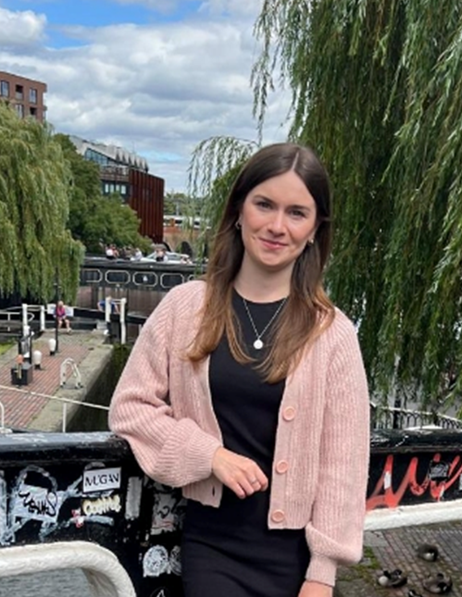
Message from Charlotte:
I just wanted to say a huge thank you to my schools, Clavering Primary School, Magna Carta Primary Academy, St Marys CofE Foundation School, Newport Primary School and Joyce Frankland Academy, for making me feel so welcomed over the past two years!
I have really enjoyed working in each of your schools, being part of the school community, delivering groups and working with parents and young people.
I have really enjoyed my time at Mind in West Essex! Take care everyone!

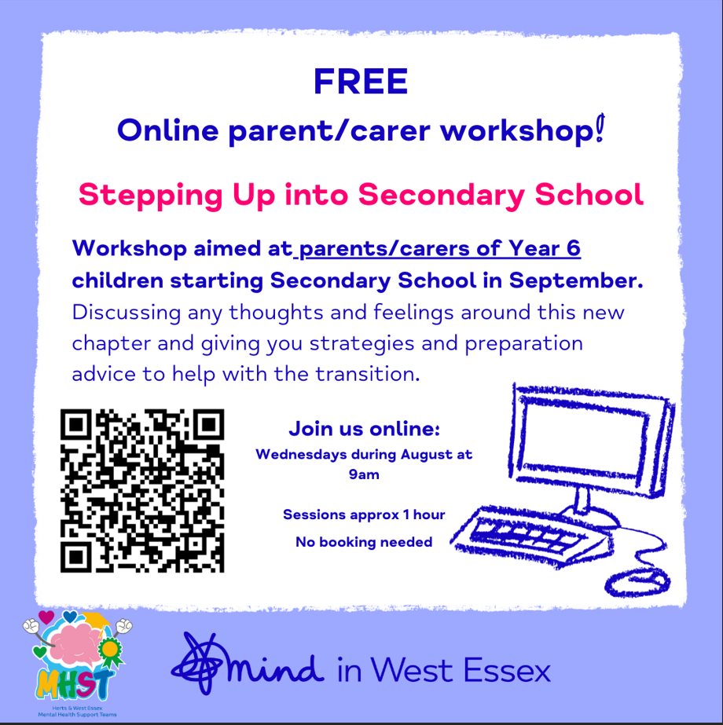

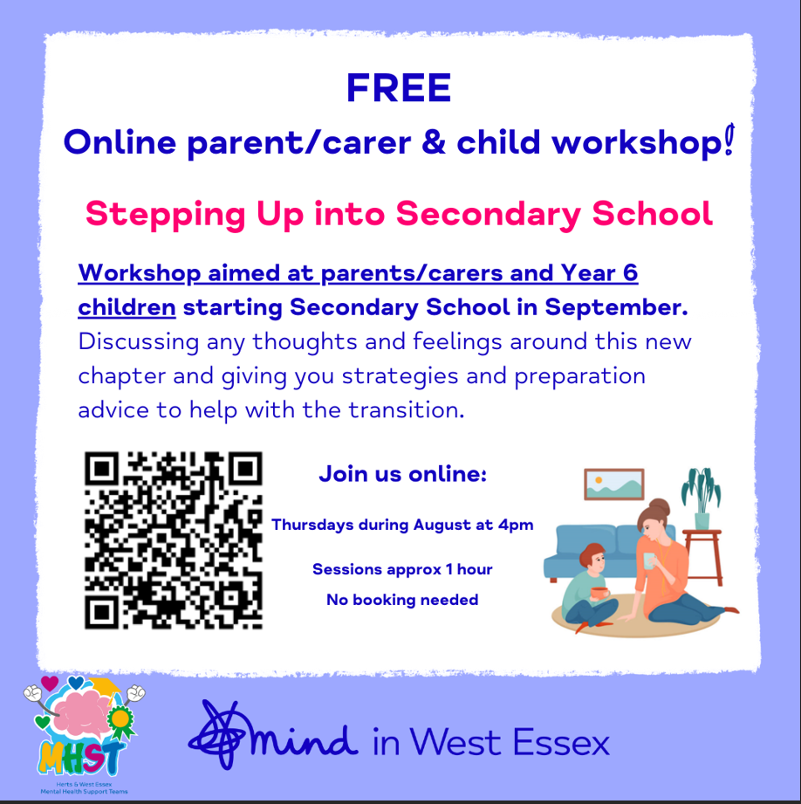


MINDFULNESS WORD SEARCH
L | E | V | A | R | B | M | D | V | C | S | P | I | P
U | I | C | E | G | U | R | N | H | U | L | E | E | E
F | L | H | O | S | A | T | I | A | I | O | A | V | T
T | G | E | E | N | T | J | K | P | R | V | C | I | R
C | T | N | F | L | T | K | E | P | L | I | E | T | V
E | L | A | I | G | P | E | J | Y | R | N | F | I | P
P | E | N | L | R | O | F | N | O | E | G | U | S | T
S | P | W | J | I | A | F | U | T | F | G | L | O | A
E | Y | I | L | F | T | C | C | L | B | U | P | P | V
R | T | S | Y | T | H | O | U | G | H | T | F | U | L
D | W | E | L | U | R | J | L | I | U | J | I | Y | C
C | S | T | L | C | P | L | U | F | D | N | I | M | F
P | S | I | O | L | J | O | Y | F | U | L | Y | I | E
U | L | R | J | V | G | N | O | R | T | S | T | A | I

CONTENT THOUGHTFUL BRAVE LOVING JOLLY WISE
MINDFUL RESPECTFUL JOYFUL POSITIVE PEACEFUL KIND
STRONG HAPPY CARING HELPFUL


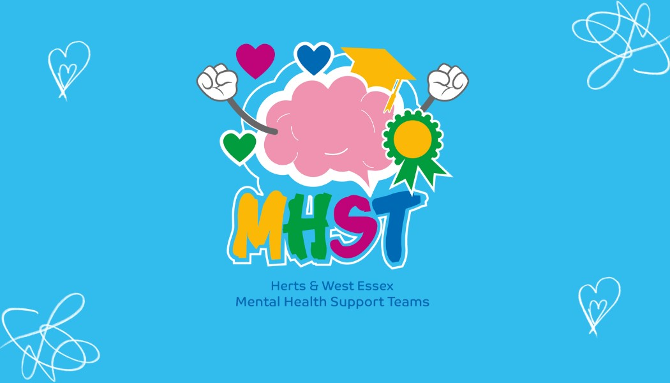

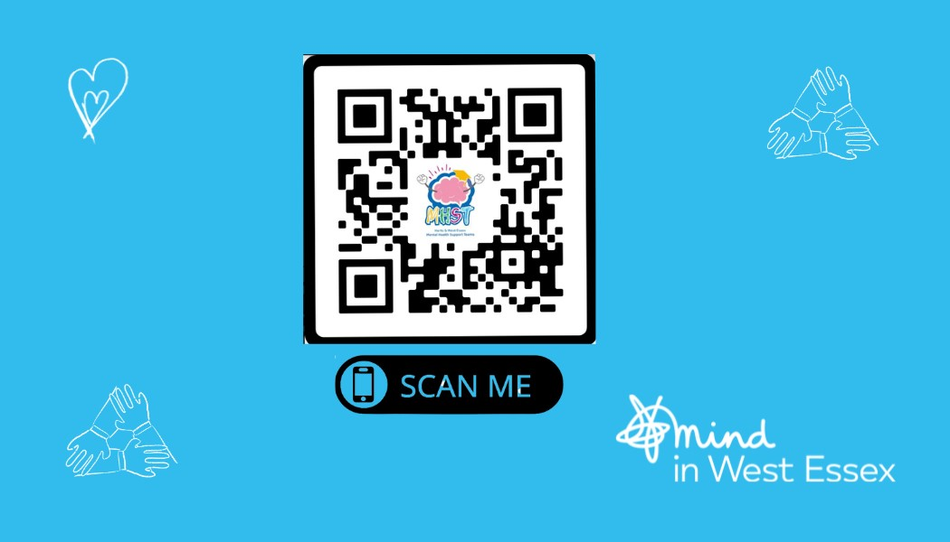

Scan the QR code to visit our website.
We offer useful self-help resources.

If you would like to contact us with any queries, please call Sally Cowan on 07935 064728 or email on mhsuttlesford@mindinwestessex.org.uk or scowan@mindinwestessex.org.uk

Mike, Helen & Sally were asked to go along to give a presentation on mental health and wellbeing to the Henham & Elsenham scouts. The session was informative, and the scouts got involved naming different emotions and how they feel in the body. Diet, exercise and sleep management were spoken about too. Thank you to the scout pack for being so engaged with us and for all the participation during the session.



