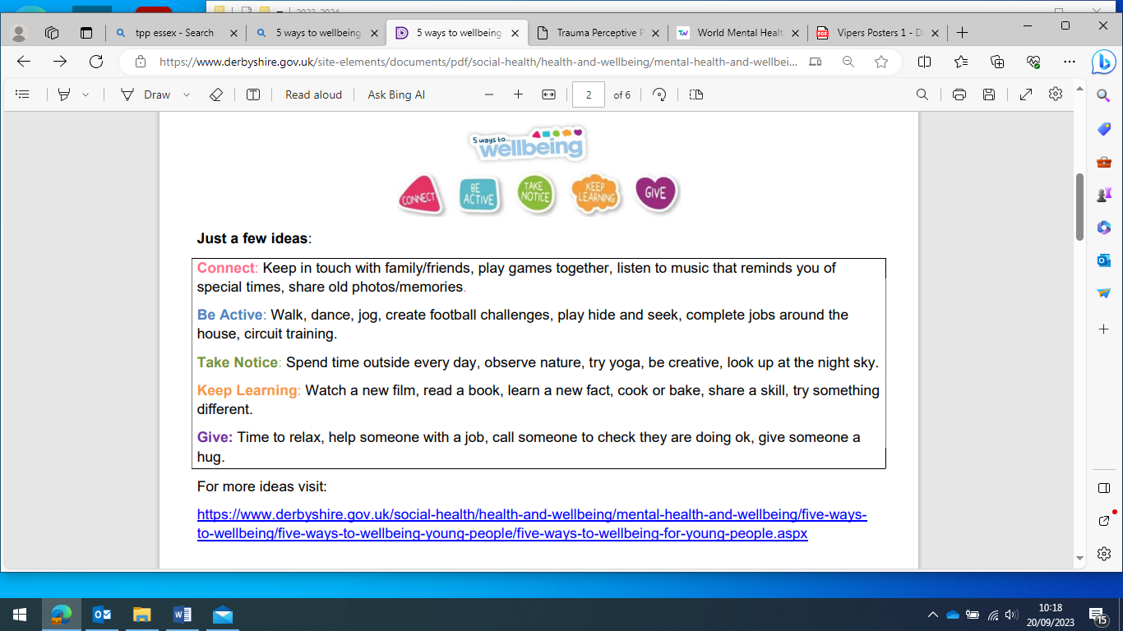
Miss Sneath’s Autumn Wellbeing Challenge! As you complete the challenges with your family, colour them in and then return the form to Miss Sneath once you’ve completed them all! 

