Area of Concern | Area of Concern | Area of Concern | Area of Concern | Area of Concern
Low self-esteem  Social challenges  Low resilience | Struggling to communicate  Feelings  Low resilience | Low resilience  Problem solving  Coping skills | Transition worries  Lack of confidence | Low resilience  Emotional distress  Loss  Low empathy
 | 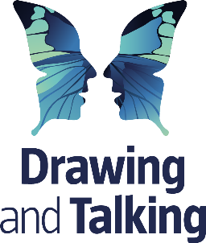 |  |  | 
Wellbeing Coaching | Drawing & Talking | Brain Buddies  Emotion Explorers  Inner Wings | Stepping-up; workshops;  1:1 Wellbeing Support | Art Therapy / Counselling
Coaching psychology supports young people to develop wellbeing and resilience and protects their mental health, helping them to cope with whatever life brings. | Drawing enables a child to express, in a visual form, worries from deep in the mind that they would not be able to talk about. | Recognise, name and understand feelings. Develop strategies to regulate emotions through self-care, self-calming strategies and thinking strategies. | Understand and share feelings; prepare year six children for their next step up; help other children feel ready for their next year group. | Provides mental health and trauma recovery support. Helps children cope better with their feelings and navigate stressful situations.
Who | Who | Who | Who | Who
Pastoral Lead | Pastoral Lead | Emma Codd – EMHP  Class based sessions  Teachers | Emma Codd – EMHP  NHS professionals  Pastoral Lead  Teachers | Kids Inspire  YCT  Next Chapter

